**Objective**

Create a landing gear that is weight optimized by utilizing the SolidWorks Topology Optimization.

The landing gear will also serve as the aerodynamic fins and thus must maintain a fin-shaped geometry. Landing gears will be made of Aluminum Alloy 2024 because of its high strength to weight ratio.

**Design Assumptions**

Loading is based on the empty mass of the SpaceX Starship because of its similar dimensions.

This results in a total loading weight of

**Base Geometry**

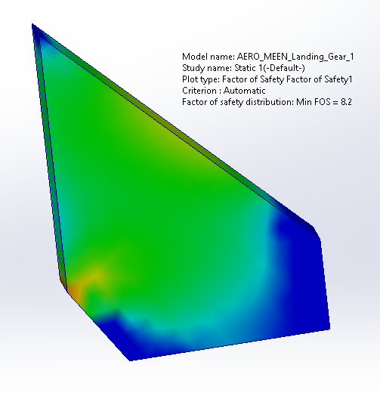

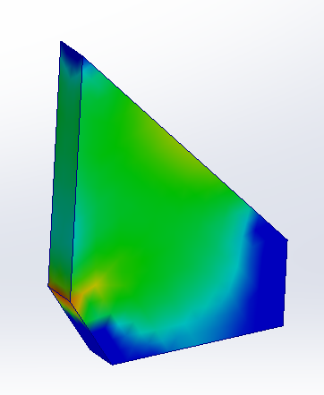

**FOS 8.2**



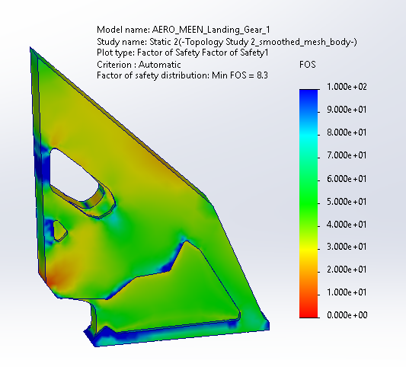

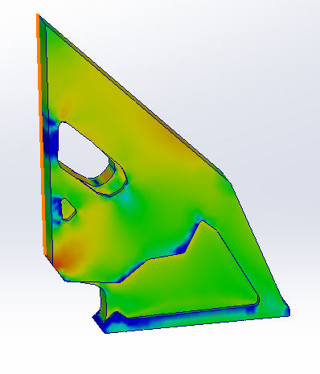

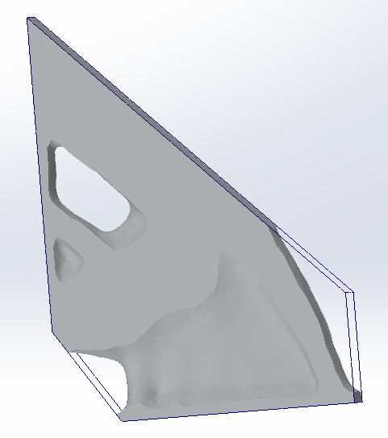

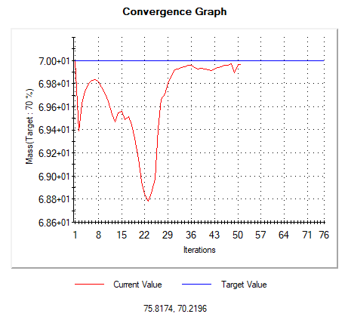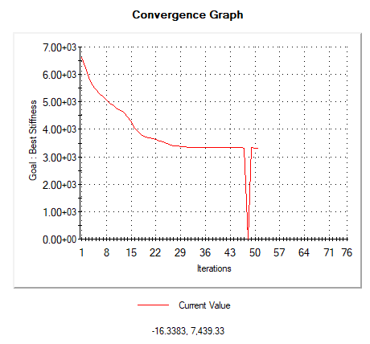

**Result 74%**